**DAILY ASSESSMENT FORMAT**

|  |  |  |  |
| --- | --- | --- | --- |
| **Date:** | 18/05/2020 | **Name:** | Davis S. Patel |
| **Course:** | TCS ion | **USN:** | 4AL16EC045 |
| **Topic:** | Communicate to Impress  Deliver Presentations with Impact  Develop Soft Skills for the Workplace | **Semester & Section:** | 8th- A |
| **GitHub Repository:** | Davis |  |  |

**FORENOON SESSION DETAILS**

**Image of the session –**

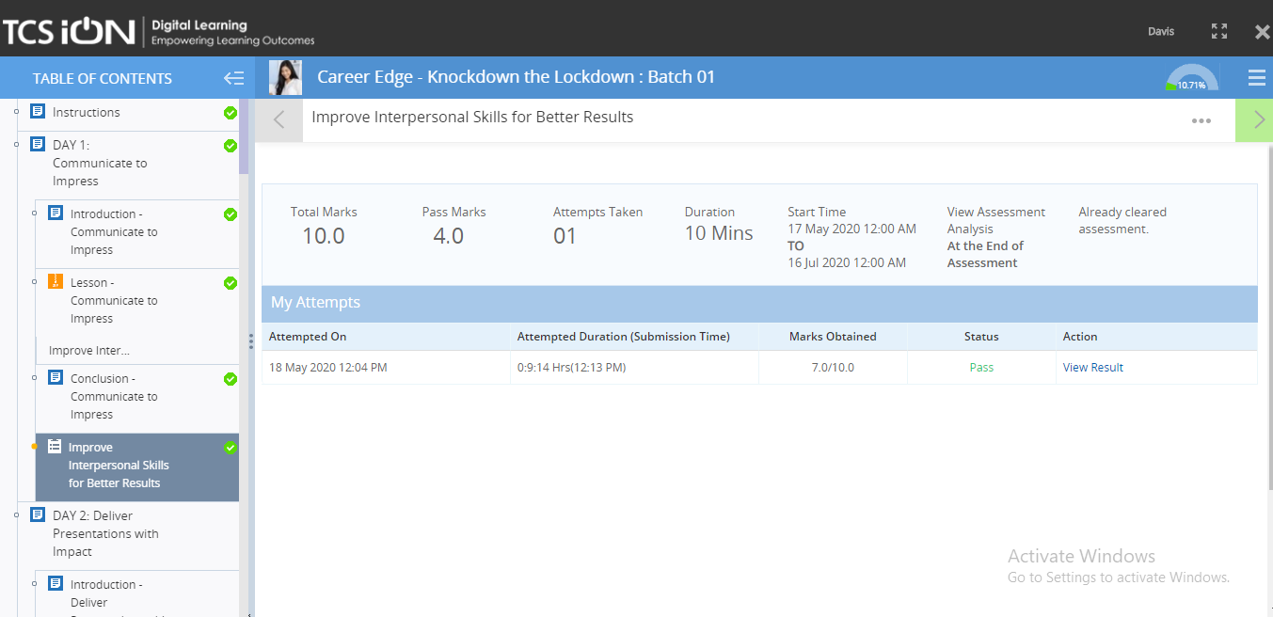

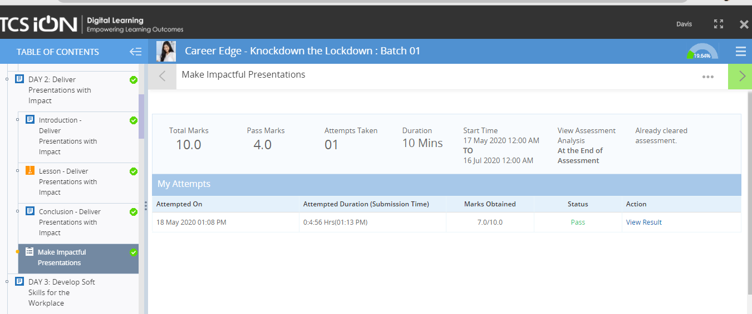

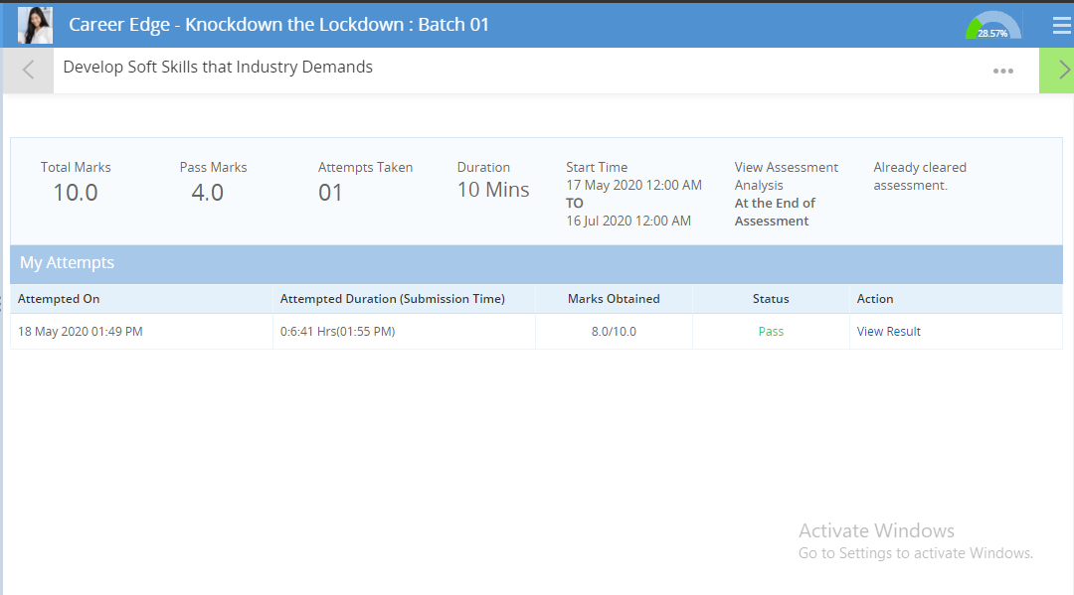

**Report –**

**Communicate To Impress-**

In this module I learned how to communicate effectively using a combination of verbal and non-verbal communication methods.

Effective communication at work is essential for organizations to be able to operate efficiently and accomplish their goals, both monetary and otherwise. Most of us have worked at a place that had terrible communication and have seen the resulting chaos that ensues. Without communicating, employees would not know what is expected of them, managers would be frustrated with their results and no one would get along.

Being a good listener is one of the best ways to be a good communicator. No one likes communicating with someone who cares only about putting in her two cents and does not take the time to listen to the other person.

Being a good listener is one of the best ways to be a good communicator. No one likes communicating with someone who cares only about putting in her two cents and does not take the time to listen to the other person.

**Deliver Presentations with Impact-**

In this module I learned how to plan, prepare and present a presentation which will leave a lasting impression on the audience.

Delivering effective and powerful presentations is critical to [business](http://www.forbes.com/business/) success. It’s about making an impact that influences your audience, whether you are an entrepreneur pitching investors, a small business owner pitching a product to a retailer or potential customer, a startup presenting a new initiative, or a manager asking for budget or staffing resources.

Whatever the purpose is for the presentation, it’s about your purpose or message, what you know, your passion, and your delivery. It’s not about what’s written on the slides.

If you are making a point, be clear and concise on your slide. Eliminate as many words as possible, use graphics as mentioned above, and, if you are creating a graph or using a table to show information, simplify them down to the essential elements that matter. Don’t just take a standard Excel graph and copy it onto your slide. Either simplify the Excel graph or create a simplified graphic in PowerPoint instead.

**Develop Soft Skills for the Workplace –**

In this online course I learned on Develop Soft Skills that Industry Demands ,the importance of maintaining a healthy relationship in a work environment and how to differentiate between soft skills and hard skills.

Developing soft skills is a (sometimes uncomfortable) process, because employees must first engage in a little self-reflection before they’ll know which soft skills training they need. This can be tough, but also rewarding. Developing soft skills like resilience, emotional intelligence and agility is a great way to make your workforce change-ready. Seminars and training programs offered at local events or conventions can be a great way to teach employees what soft skills development is, and why it matters.

Practice! This is how to develop soft skills in employees. After all, it would be pointless to develop employees’ collaboration skills and then isolate their work responsibilities. Outdoor retreats provide a fun and risk-free environment to practice soft skills like teamwork, collaboration and communication. Opt-in assignments give employees the chance to practice problem-solving and creative thinking skills.